Intro to Section 4

Disease management

In order to run a successful farm and deal with pests and pathogens in the real world it is best to form a cohesive plan that brings together cultural, biological, physical, and chemical controls in a responsible and sustainable manner known as Integrated Pest Management (IPM). Combining the methods discussed in this book positions farmers along an IPM path that should reduce fungal pathogen problems and limit the economic injury which they can impose upon a farm. Combining these methods with effective pest controls and remaining flexible in the face of changing threats is important for success as a farmer. The goal of this section is to educate growers about how IPM programs can mitigate fungal pathogens.
Integrated pest management: explaining how cultural, biological, and chemical pest and pathogen management options need to be synthesized together to create a resilient system (i.e. IPM).

Chapter 19
Plant Defenses

Introduction

Most plants are sessile organisms affixed to an immobile substrate. Plants usually have the ability of movement, as occurs when a leaf tracks the movement of the sun through the day (phototropism) or a root orients its growth downward (gravitropism). However, such movements are insufficient to evade predators or pathogens. Instead plants rely on a variety of other mechanisms to prevent and reduce herbivory and disease. Plant defenses begin first with physical structures. If these are overcome a litany of chemical protection provides a vast arsenal with which to mount counterattacks. While plant immune defenses are much different than animals, they do have reactive immune systems which share some of the same mechanisms as our own. We will discuss some of these features in this chapter, beginning with physical structures, then moving on to summarize chemical defenses and reactive plant immunity as they occur in pattern- and effector- triggered immunity (PTI and ETI) systemic acquired resistance (SAR) and induced systemic resistance (ISR)

Physical Defenses
All plants have cell walls, which give them structure and protect them from external threats. However, because they can’t move like animals, plants have evolved other strategies to fend off predators and pathogens. The first line of defense is physical barriers, much like how our skin protects us. For example, woody plants have bark, which functions like a shield. On plant parts without bark, like leaves, a waxy cuticle on the epidermis helps protect against both abiotic and biotic stressors.
Table 19.1. Trichome types found on Cannabis
Type |  | Approximate sizes | Features
Non-glandular | Non-cystolithic | 70-125 μm | Thin, unbranched, simple in shape. Unicellular. Occur most densely on the underside of leaves and bracts.
 | Cystolithic | 250-370μm | Similar to non-cystolithic in shape, but larger. Contains cystoliths, calcified outgrowths of the cell wall, at their base.
Glandular | Bulbous | 10-30 μm | Diminutive trichome with secretory cells. Variable structure.
 | Capitate sessile | 25-100 μm | Large glandular head with secretory cells often attached by several cells, but only one cell high.
 | Capitate-stalked | 70-150 μm, stalk up to 1000 μm | Large glandular head with secretory cells situated on top of a slender, multicellular stalk.
 | Antherial Sessil | 25-100 μm | Occur only on the anthers and calyx of male flowers.

Plants also have trichomes, tiny hair-like structures that are especially abundant in Cannabis (Table 1, Fig 1). Trichomes have several roles, including reducing water loss, shading leaves from intense light, deterring herbivores, and even secreting chemicals that defend the plant. Cannabis produces at least three types of trichomes, which contain cannabinoids, terpenes, acids, and polyphenols. The types and sizes of trichomes vary depending on the plant's genotype and age.
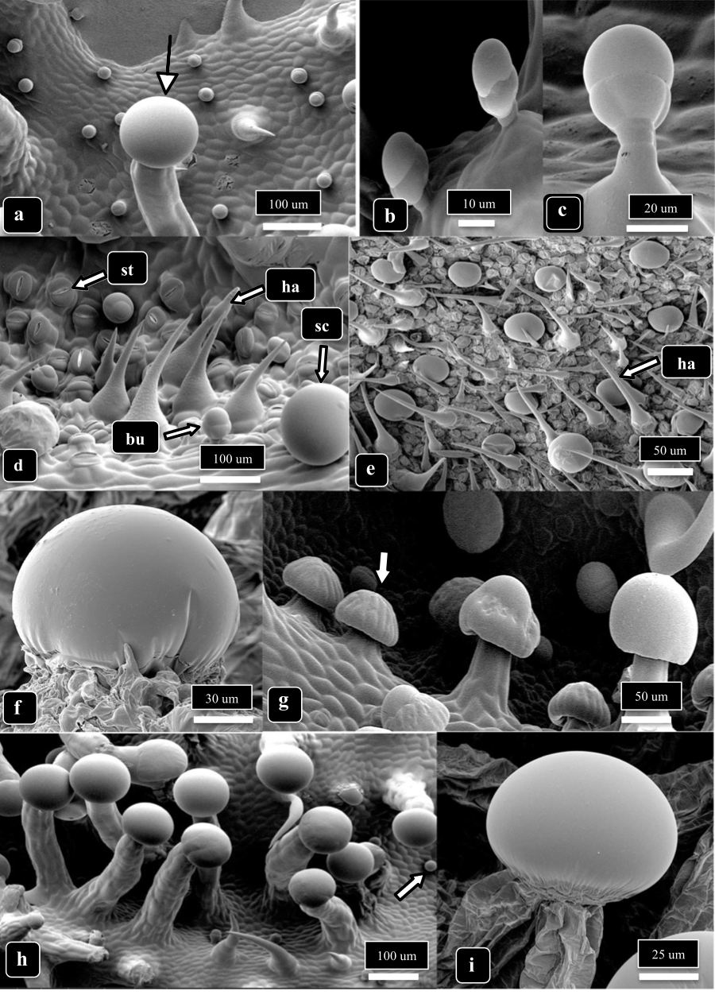
Fig 1. Scanning Electron Micrograph (SEM) showing different types of trichomes Cannabis plants can produce. The arrow in a) is pointing to a stalked capitate trichome, b) & c) are showing bulbous trichomes, images d) & e) show bulbous (bu) non-glandular (ha) and sessile capitate (sc) trichomes as well as leaf stomata (st), f) is a zoomed-in image of a sessile-capitate trichome, the arrow in g) is pointing to a presecretory sessile capitate trichome with stalked-capitate trichomes to the right, the arrow in image h) points to a small bulbous trichome and stalked-capitate trichomes to the left, and image i) is a close up of the head of a stalked-capitate trichome. From Punja et al 2023.
Internally, plant cells have a selectively permeable plasma membrane surrounded by a cell wall made of lignin, cellulose, and xylan. Roots also have a specialized internal barrier called the Casparian strip, which ensures that water must pass through the plasma membrane of cells before entering the vascular tissue to be transported throughout the plant. This selective permeability helps plants exclude large molecules and potential pathogens unless specific transport channels allow entry.
Stomata, the openings on the plant surface that allow for gas exchange, are another vulnerable point for infection. Fungi, for example, often target stomata by forming an appressorium, which allows them to bypass the leaf cuticle and epidermis to enter the plant (Fig. 3). Similarly, root hairs are commonly targeted by microbes as an entry point.

Chemical Defenses
Plants produce a variety of secondary metabolites, which are chemicals not directly involved in the plant's normal growth processes but are crucial for defense. These include terpenes, phenolics, alkaloids, phytoalexins, defensins, and enzymes. Secondary metabolites play a significant role in plant health by mediating interactions with microbes and defending against both microbial and animal attacks.
Phytoalexins are a class of secondary metabolites produced or activated only after contact with a pathogen. While the term "phytoalexins" is sometimes used to refer to all plant defense chemicals, true phytoalexins are only produced after infection, unlike chemicals that are present pre-infection. An ongoing effort to categorize the wide variety of phytoalexins and plant defense chemicals is summarized in Table 19.2.
Table 19.2. Chemical defenses of plants involved in microbial defenses.

Non-Nitrogen Containing | Terpenes/Terpenoids  Flavonoids  Lignans  Phenylpropanoids  Coumarins  Tannins  Steroids  Saponins  Polyacetylenes  Fatty acids
Nitrogen Containing | Alkaloids  Non-protein amino acids  Amines  Alkamides  Lectins  Peptides  Polypeptides  Enzymes  Defensins  Small interfering RNAs  Nucleic acid extracellular traps

Plant Immunity
While plants lack an adaptive immune response like animals, they are far from defenseless. Plants have innate immune systems that allow them to respond to pathogens and pests by altering their growth and ramping up their chemical defenses. When triggered, plants can activate an immune response that affects the whole plant.
Depending on the trigger, the immune response can be either induced systemic resistance (ISR) or systemic acquired resistance (SAR). ISR is typically a milder response, often triggered by interactions with beneficial microbes like Rhizobia or mycorrhizae. On the other hand, SAR is a stronger response that is usually triggered by a pathogenic attack. Both ISR and SAR prime the plant's immune system, preparing it to better defend against future threats.
Plants recognize invaders through two main immune responses: pattern-triggered immunity (PTI) and effector-triggered immunity (ETI). These responses are critical for detecting and fighting off pathogens. You can find more details on these systems in Table 3, where we list key abbreviations and terms related to plant immunity.
Table 19.3. Abbreviations of commonly encountered terms when discussing plant immune responses.

ISR | Induced Systemic Resistance
SAR | Systemic Acquired Resistance
PTI | Pattern Triggered Immunity (aka Basal Immunity)
ETI | Effector Triggered Immunity
MAMPs | Microbe-Associated Molecular Patterns
DAMPs | Damage-Associated Molecular Patterns
NAMPs | Nematode-Associated Molecular Patterns
PAMPS | Pathogen-Associated Molecular Patterns
PGPR | Plant Growth Promoting Rhizobacteria
PR-proteins | Pathogenesis-Related proteins
ROS | Reactive Oxygen Species
R-genes | Resistance genes involved in ETI, most often of the nucleotide binding, leucine rich repeat (NB-LRR) or pattern recognition receptor protein (PRR) classes

In short, plants have evolved a complex and multi-layered system of defense to protect themselves from predators, pathogens, and environmental stressors. From physical barriers like bark and trichomes to sophisticated chemical responses and immune signaling pathways, plants use a variety of strategies to ensure their survival and fitness.
Systemic Acquired Resistance (SAR) and Induced Systemic Resistance (ISR) are two ways plants boost their defenses when under attack by pathogens or pests, and both rely on different pathways to get the job done.
ISR typically kicks in when a plant's pattern-triggered immunity (PTI) is activated. This response is mainly driven by plant hormones like jasmonate and ethylene. On the other hand, SAR is tied to effector-triggered immunity (ETI) and involves a different set of hormones, primarily salicylic acid. While both ISR and SAR help plants defend themselves, they’re triggered by different conditions and involve slightly different processes, though they do share some overlapping effects.
For example, SAR is associated with the production of pathogenesis-related (PR) proteins and a hypersensitive response, where cells around the infected area undergo programmed cell death to prevent the spread of the pathogen. ISR, on the other hand, doesn’t produce these PR proteins. But both ISR and SAR activate the production of callose, a substance that strengthens cell walls and helps stop pathogens from spreading throughout the plant.
Interestingly, ISR can be triggered by beneficial bacteria (like plant growth-promoting rhizobacteria), which was actually how ISR was first discovered. And while ISR and SAR are distinct, they share enough similarities that both help reduce disease and pest severity across the entire plant.
Table 19.4. Features of SAR and ISR
Systemic acquired resistance | Induced systemic resistance
- Triggered by biotic and abiotic stressors (MAMPs/DAMPs/Abiotic)  - Hypersensitive response- Localized Reactive oxygen species (ROS) burst causes host cell death around area of infection  - Pathogenesis-related proteins (PR-proteins) accumulate  - Callose production | - Salicylic acid ‘independent’  - Mediated by jasmonate/ethylene signal transduction  - Triggered by biotic inducers (MAMPs)  - Callose production

Breeders can take advantage of these natural defense mechanisms by selecting plants with stronger innate immune systems. Through breeding, they can create plants with genetic traits that enhance their ability to fight off diseases and pests, giving them a better chance of surviving in the wild.
In summary:

- Plants have evolved defense strategies to protect themselves from potential pathogens including physical and chemical mechanisms
- Plant immune system includes Induced Systemic Resistance (ISR) and Systemic Acquired Resistance (SAR)
- Depending on what triggers the plant immune response the plant may produce chemicals intracellularly or extracellularly
- Immune response increase the plants ability to defend itself against pathogens

Chapter 20

Prevention of Disease Outbreaks

The Coming Plagues: The Cultural Ecology of Epidemics
Cannabis cultivation, especially in areas where it has a long history, is facing a rise in pest and pathogen problems. With farms expanding and more growers connecting across regions, pests and pathogens are spreading. Common pests like the two-spotted spider mite, as well as more recent threats like the bhang aphid, are becoming widespread. These pests carry fungal pathogens like bud rot (Botrytis cinerea) and powdery mildew (Erysiphales), and some even spread viruses and bacteria.
As the Cannabis industry grows, both in size and interconnectedness, problems that used to be isolated are now more widespread. Legal Cannabis farming, whether for hemp or THC-rich plants, creates an environment where pests and pathogens have easier access to more crops. The monocropping of genetically identical clones increases the risk of pests and pathogens evolving into more resilient strains.
Prevention of Pathogens:
To reduce pest and pathogen problems, it’s crucial to start with clean plants. Growing from seed, rather than clones, helps avoid introducing diseases. If clones are necessary, quarantine and proper cleaning procedures can help. It’s also a good idea to test plants for known viruses and pathogens before introducing them into your garden.
Sterilizing Garden Tools

An integral part of any IPM strategy is cleaning and sterilizing garden tools after each use or especially in between planting seasons. Uncleaned tools can act as a vector for pests and pathogens, including fungi, bacteria, and viruses.
Any obvious signs of soil or plant materials should first be rinsed off any tool. Then the tool can be cleaned with a brush and a mild soap solution to further remove any organic materials. Once the tools have been rinsed and washed, they can then be sprayed with and/or soaked in a solution to disinfect any microscopic organisms.
Disinfecting solutions include solutions of 10% sodium hypochlorite (Bleach), >70% isopropyl alcohol, 2% sodium hydroxide, and 20% milk fat. Depending on the disinfectant and concentration used will determine how long tools need to remain in contact with the solution for effective killing properties. Gloves and safety glasses should be worn whenever working with disinfectants because many of these chemicals can be harmful to skin and membranes.
After tools are disinfected they should be rinsed again with water and then allowed to dry before returning the tools to the storage location. This not only ensures clean tools when needed but also increases the longevity of the tool and prevents corrosion from occurring.
Pests and pathogens can be introduced to healthy crops in a number of different ways so best practice is to reduce any unintentional inoculations by maintaining a clean garden space and by using clean tools and equipment.

Cannabis farmers need to be mindful of planting intensity. The more densely plants are packed together, the more likely pests and diseases will spread. Regulators should consider allowing more space between plants to help reduce these risks. Practices like perpetual growing (where farms never have downtime) or planting from cuttings create opportunities for pests to have consistent food sources and habitats, so managing these "green bridges" is key to breaking disease cycles.
Table 21.1. Prevention of pathogen introductions is the first step to preventing disease outbreaks. Many sources for contamination of pristine grow rooms and locations can be identified and controlled. Alternatively, in areas where exposure to ambient inocula is inevitable (outdoors and most greenhouses), proper prevention and control strategies should be implemented before symptoms arise (integrated pest management). With vigilant prevention strategies, hopefully they never will.

Contamination source | Risks assessment | Mitigation
Clone market  · Clones are a primary source of pest/pathogen introductions | · Clones may bring along any biotic issue from the garden from which they originate along with them  · Long lived clone-only strains may accumulate viruses and latent endophytic pathogens | · Quarantine any new plant material  · Perform preventative treatments pests/pathogens  · Tissue culture may be used to clean contaminating pests, endophytes, and even viruses from plant tissue
Employee movement:  · Movement of pests within a grow and between grow areas at the same farm  · Often employees work at multiple farms  · Increased concern for indoor/year-round grows | · Trimmers are among the most promiscuous workers among farms  · All farm workers who make direct or indirect contact with plants pose a risk | · Separate trimming facilities; have clean room and areas separate from living plants.  · Have washrooms and work uniforms on site; incorporate hygiene protocol as a normal part of the job
Deliveries and vehicles:  · Vehicles can carry a lot of seeds, spores, and pests from one site to another | · Farm suppliers will be visiting more than your farm in their truck  · Service trucks (plumber, electrician, ISP) all will also be servicing other farms  · Employee and visitor parking | · Place parking lot as far from growing areas and intakes as possible  · If a vehicle is required for a job, wash it before allowing near grow areas  · Encourage/pay for off site employee car washes  · Have a car washing station away from grow areas and intakes
Tools and equipment | · Rental equipment should be assumed to be contaminated  · On-farm tools can spread pest/pathogens among plants and growing areas | · Wash rental equipment before use in growing areas  · Regularly clean and sterilize tools between growing areas  · Sterilize tools between use on different plants; this is critically important when moving between mother plants
Seed supplier | · Seed surface may be contaminated with pathogen (or beneficial) propagules  · Seed may internally harbor a pathogen (or beneficial symbiont) | · Surface sterilize seed  · Treat seed with known beneficials, possibly following seed sterilization  · Heat treatment of seeds may clear internal infections, but will greatly reduce seed viability

Managing Pest and Disease Spread:
- Rotate crops and plant species that can't host pests.
- Use hot composting to kill plant debris that may harbor pests.
- Implement clean growing practices, like sterilizing tools and using filtered air.
- Interplant Cannabis with other species to repel pests.
- Introduce trap plants like calendula to monitor and remove pests before they spread.
21.2 Cleaning seed for planting. Seed may be a source of microbial contamination, mostly on the outside surface though also sometimes inside the seed or even within the plant body itself (See chapter 13 Table 2 for more information).

 | Process | Pros | Cons
Surface sterilization | - 1.5 % v/v NaCLO for one minute.  - Rinse in sterile H2O  - Air dry seed on paper towels to plant immediately; Air dry at 30C 85F overnight (8-12hrs) for storage. | - No seed damage when performed directly prior to planting | - If performed before seed storage, it will reduce viability over time
Systemic fungicide sterilization | - Apply as directed on label | - Kills internally infested seed | - Systemic fungicides may persist  - Not organic  - None approved for use on Cannabis
Hot water treatments | - Preheat seeds to 38-43C (100-110F)  - Stir into 50C (122F) H2O* for 15-30 minutes  - Transfer to cool water immediately  - Air dry seed on paper towels to plant immediately; Air dry at 30C 85F overnight (8-12hrs) for storage. | - Kills internally infested seed | - Precise duration and temperature are unknown for Cannabis seed, and may vary based on seed characteristics (which can be highly variable among Cannabis varieties)  - Some seed is inevitably damaged.  - If performed before seed storage, it will greatly reduce viability over time
*Temperature must be accurate and precise throughout the treatment.
Table 21.3. Break the “green bridge:” methods for eliminating carry-over pests from previous crops. The lifecycle of pest and disease organisms should be disrupted whenever possible to prevent continuation or amplification of pest problems the farmer may experience during a particular crop cycle. Perpetual growing styles increase the risk associated with pest accumulation, when compared to seasonal agriculture.
Animal Pests and Pathogen Outbreaks:
Insects and arthropods play a significant role in spreading fungal pathogens. They can carry spores and create wounds in plants that allow fungi to enter. For example, pests like aphids can bring in viruses, while their excretions can create environments where fungi, like Botrytis cinerea (gray mold), thrive.

Outdoor/seasonal growers |  | Indoor/perpetual greenhouse
Rotate crops | - Plant alternative crops that cannot host pest organisms in between crop cycles  - Use Brassica plow under crops to treat field problems associated with Pythium, Fusarium, and Verticillium  - Reduce plant waste left in the field or work into top layer of soil allowing for quicker decomposition and pathogen antagonisms  - Hot-compost, heat-kill, or otherwise destroy pest containing plant debris | Maintain clean grow | - Filter incoming air  - Use positive pressure rooms to prevent unfiltered air leaks  - Require cultural practices for sterile rooms (clean clothes, shower areas, ect.)  - Clean grow areas periodically  - Consider avoiding perpetual grows in pest prone situations
Interplanting | - Interplant Cannabis with a diversity of other species  - Plant multiline seed with varying disease resistance  - Use Push/Pull repellant/trap plant system* | Environmental manipulations | - Take advantage of your control over the environment to make it unfavorable for your problem pests and pathogens
All cultivators
Grow from seed or clean, tissue-cultured plants | - Eliminate contamination from clones  - Eliminate the need for a perpetual mother area
Trap plants | - Use indicator and trap plants, such as calendula, to monitor and remove pests.
*Push/Pull companion planting uses plants which alternatively repel (push) or attract (pull) to direct plants pests away from the canopy (push plants interplanted into the canopy) towards pull plants (interspersed and along field edges). Pull plants can act as trap plants. Trap plants should be monitored as sentinels of pest invasions and are removed and destroyed before pests or pathogens can use trap plants as a food source for population growth. Precise plant combinations for Cannabis pests have not been researched. Mixing applied-plant-treatments with companion planting may simplify the system until effective planting combinations are specified. For instance, pest-attractive trap plants can be planted on the perimeter of a crop, then only the crop itself is treated with an appropriate pest deterrent (ie. essential oil product). Pests will prefer the still attractive trap plants to the treated crop, increasing the effectiveness of applied pest and pathogen treatments. Untreated Cannabis plants could be used as trap plants -just know they are destined for sacrifice, so don’t get attached and keep them too long.

Clonal Degradation:
A common issue in Cannabis cultivation is the decline of vigor in long-lived, clone-only plants. This isn’t unique to Cannabis, as many agricultural crops face similar issues with clonal propagation. The main cause of decline is often the accumulation of pathogens rather than genetic changes. New research has identified hop latent viroid as the cause of "dudding," a condition affecting some clonal plants.
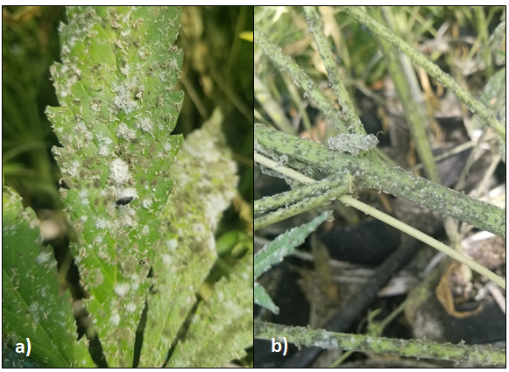
Figure 21.2. a. A leaf with powdery mildew (G. ambrosiae) colonies (white mycelium) interspersed among Botrytis colonies (grey) and black, sooty mold (Alternaria). b. Prolific botrytis growth on the stem is supported by aphid honey dew (excrement) well before the underlying plant tissue is susceptible to necrotrophic infection. Aphids and white flies infested this greenhouse planting, precipitating devastating mold epidemics. All of these mold varieties create prolific conidia which are moved by wind as well as on and inside insect bodies.
Additionally, environmental factors can cause epigenetic changes, altering how genes are expressed without changing the DNA sequence itself. Over time, these changes can affect plant health and vigor, but tissue culture techniques can help clear these issues by resetting the plant’s internal state and potentially removing accumulated pathogens.

Epigenetics:
Epigenetics refers to heritable traits that are unexplained by alterations in the DNA sequence itself. In popular usage, the term is often used to refer to culturally inherited characteristics, traditions, and knowledge that operates “above” (i.e. epi-) the level of genetics: a force acting to affect human phenotypes across generations, but independent of the hereditary molecule, DNA. But the epigenetics as discussed in biology is not unique to humans, and is not dependent on culture.
Epigenetics changes are the result of real, physical changes in the structure, though not sequence, of DNA and the histone proteins around which it is packaged. These physical changes are the methylation of DNA or variously complex modifications of histones (usually methylation and acetylation). These physical changes to the DNA molecule and their packaging proteins results in persistent alterations in gene expression. This is a major mechanism controlling gene expression which permits the specialization of cells and the formation of tissues in complex, multicellular organisms. Among humans, cultural epigenetics, including nutrition and lifestyle, may induce physical epigenetic changes in individuals characteristic of those cultural environments (Jablonka, 2016). In some cases these induced epigenetic changes may reinforce the culture which induced them, leading to a positive feedback loop.

In summary:

- As Cannabis cultivation becomes more mainstream, diseases can spread to new regions of the world
- Having IMP protocols in place can help to decrease the spread of pathogens
- Being aware of common disease vectors can alleviate the spread of pests from one farm to another
- Serial cloning lead to changes in phenotypic expression of a plants genes and can alter disease susceptibility of that particular plant variety

Chapter 21

Soil Treatments For the Reduction of Plant Pathogens:

Although farmers and growers strive to prevent pests and pathogens from infiltrating their systems, these insidious organisms often manage to creep in. This highlights the importance of routine scouting and monitoring of plants to maintain crop health. Early detection of these invaders allows for more effective control or even complete elimination of unwanted pests. However, if producers find themselves facing an existing pest issue, there are still steps they can take to mitigate further problems.
The agronomic techniques used by a facility or farm will dictate the most suitable pest control approaches. For instance, a farm growing in living soil has different options compared to a hydroponic farm using rockwool. Hydroponic mediums are typically not reused, but operations that do so successfully sanitize, sterilize, and rinse the media to remove salt buildup before reuse. This strategy is highly efficient for materials such as inert pelletized clay (e.g., Hydroton) or perlite.
In contrast, farmers growing in fields do not have the same level of control over their soil as container-based soil growers do. This document focuses on methods for rehabilitating and improving soils to minimize or eliminate disease organisms, thereby reducing crop damage. The outlined methods can be used to "reset" soil that is currently causing plant health issues.

Steam Sterilization/Pasteurization
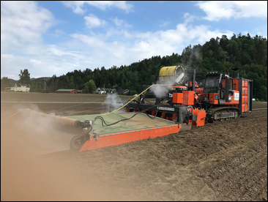
Figure 21.1. Farm machinery equipped for deep soil steaming. (wikipedia)
Steam sterilization and pasteurization are effective techniques for reducing pathogen populations and rehabilitating pathogen-infested soil (Trevors 1996, Wolf 1989). Various machinery is available for large-scale soil steaming (Fig. 1). The goal of soil pasteurization is to eliminate pathogens while preserving beneficial soil microbiota and maintaining the soil's chemical and physical properties (Trevors 1996). Fully sterilized soil may become more susceptible to pathogen invasion and should be inoculated with beneficial saprophytes once it cools (Malowany and Newton 1947). Small-scale soil sterilization can be performed using stovetop pots, pressure cookers, or metal drums on propane burners.
Table 22.1. Field techniques for steaming soil.
Steaming Method: | Description
Sheet | A large, heat resistant, insulated sheet is used to cover an area of soil. Steam is injected under the sheet and allowed to percolate through the soil for a period of time.
Depth | An area of soil is covered with a sheet, as in sheet steaming. However, permanent or temporary piping is used to create a negative pressure at depth in the soil in order to pull hot steam deeper
Hood | Hoods are steam treatment devices that operate as surface steamers (like sheet steaming). The treatment area is limited to the size of the hood.
Sandwich | Sandwich steamers are hoods that combine surface and depth steam treatment under forced pressure. This is the fastest and most efficient soil steaming method.

Soil Solarization
Soil solarization is a non-chemical, passive strategy that uses sunlight energy to eliminate or reduce soil pathogens. This method is cost-effective, easy to implement, and significantly decreases pathogenic organism populations. However, it is non-selective and can kill beneficial microbiota along with pathogens.
Typically, soil is watered and then covered with clear or black plastic (polyethylene) during warm, sunny weather (Stapleton 2000). The trapped heat pasteurizes or sterilizes the soil up to 18 inches deep. Several factors affect the efficacy of solarization, including soil moisture, temperature, solar radiation, and wind speed (Stapleton 2000). This method can significantly reduce pathogenic soil fungi, nematodes, and weed seeds. Adding green manures, composts, and organic materials alongside soil solarization may enhance its effectiveness.

Flooding
Flooding can effectively reduce certain soil pathogens, including Fusarium, Verticillium, Sclerotinia, and Pythium. By creating anaerobic conditions, flooding limits the survival of aerobic soil fungi (Newhall 1955). To achieve pathogen reduction, soil should remain flooded for at least two weeks. However, flooding carries the risk of spreading soil-borne pathogens, particularly those with mobile zoospores, such as oomycetes. Therefore, it should be conducted when nutrient leaching risks are minimal.

Green Manures
Green manures are cover crops incorporated into the soil to improve its health. These cover crops help reduce erosion, suppress weed growth, enhance soil structure, improve water retention, and add essential nutrients, such as nitrogen from leguminous crops. Additionally, tilling in green manures can reduce soil-borne pathogens by promoting a robust saprophytic community that outcompetes pathogens.
No-till farmers who chop and drop cover crops still benefit from green manures, though soil incorporation increases their effectiveness in reducing pathogenic microorganisms. Common cover crop species include legumes, grasses, and brassicas. Cover crops should be cut or plowed before seed set to prevent reseeding. Legumes, in particular, can significantly boost nitrogen availability for subsequent crops due to their nitrogen-fixing rhizobia associations.

Brassica Plow-Down Crops
Brassica plow-down crops serve as a specific type of green manure with additional biocontrol properties. Mustard family plants contain glucosinolates, which break down into isothiocyanates—chemicals known for their antifungal properties. Due to their volatility, proper incorporation into moist soil immediately after mowing is crucial to maximize their biocontrol potential.
Table 21.2. List of Brassica plants that can be used as Brassica plow-down crops.
Broccoli
Kale
Cabbage
Canola
Rapeseed
Radish
Turnip
Various Mustards
** From Larkin and Lynch 2018
Brassica plow-down crops effectively control a variety of soil pathogens, including Fusarium spp., Pythium spp., Sclerotinia spp., Verticillium spp., and Rhizoctonia spp. They can also help manage nematodes, insect pests, and weeds. Specific Brassica varieties have been developed for high glucosinolate production, such as the Caliente line.
Table 21.3. Important factors for successful planting of a Brassica plow-down crop.
Variety: Choose a variety developed for use as a plow-down cover crop that is high in allyl isothiocyanate (Caliente).
Planting: Brassica cover crops can be seeded any time spring-fall in temperate areas, and year round in warmer areas as long as sufficient moisture is available for germination and growth. Planting dates should be early enough to allow proper biomass production before flowering occurs, as plow-under occurs before seed set. About 60-70 days should be sufficient for maximum biomass production.
Cultivation: Nitrogen and Sulfur should be applied in a 6:1 ratio to ensure sufficient biomass and Glucosinolates production within a range of 75-125 lbs N/ acre. The majority of these nutrient applications will become available for the following crop.
Plow-down: Most of the isothiocyanate volatalizes from mowed brassica cover crop within 20 minutes. For this reason avoid hot, dry, sunny weather for the plow down. It is important to till mustard cover crops into moist soil immediately after mowing. For small areas, tarps can be used to lengthen the persistence of isothiocyanate in the treated soil.
Rest: Wait a period of at least 2 weeks before planting the crop plant, longer in cool weather.

Adjusting Soil pH with Lime or Sulfur
Soil pH adjustments can influence microbial populations, benefiting or suppressing certain pathogens. Many soil-borne fungal pathogens, such as Fusarium and Verticillium, thrive in acidic soils and can be controlled by raising soil pH with lime applications. Conversely, Phymatotrichum root rot occurs in alkaline soils, necessitating proper pH diagnosis before treatment.
Table 22.4. Commercial forms of lime and sulfur that may be applied to cultivated field soil or potting mixes. When choosing which additive to use it is important to take into account how it will react in your specific soil environment.
Product common name | Chemical formula | Effect on pH | Speed of action
Agricultural lime | CaCO₃ | + | slow
Dolomite lime | CaMg(CO₃)₂ | + | slow
Hydrated lime | CaOH | + | quick
Burnt lime | CaO | + | quick
Citric Acid | C₆H₈O₇ | - | quick
Elemental sulfur | S | - | slow
Sulfuric Acid | H2SO₄ | - | quick
Ferrous sulfate | FeS0₄ | - | medium
Gypsum | CaSO₄ | neutral
Magnesium Sulfate | MgSO₄ | neutral
Potassium Sulfate | K₂SO₄ | neutral

Suppressive Soils
Certain soils naturally suppress soil-borne plant diseases like Fusarium spp., Rhizoctonia solani, and Phytophthora spp. Cultural practices and soil treatments can convert pathogen-conducive soils into suppressive soils by encouraging beneficial microbial communities. Some suppressive soils can be used as inoculants to enhance conducive soils.
Table 21.4. Suggested biological treatment options for soils with known pathogen populations. These can be attempted alone or in combinations, permitted biological inoculations occur after any pasteurization or sterilization treatments.

Mechanism of action: | Treatment options:
Competition for resources | - Organic material can be introduced to encourage competition by resident microbiota  - Steam and/or brassica plow down treatments should be performed first, followed by re-inoculation with an aggressive saprophyte population
Allelopathic antagonism | - Introduce known antagonists to soil directly to destroy pathogen inocula, or following soil treatment to prevent recolonization
Hyperparasites | - Hyperparasites are organisms known to directly attack the pathogen species as a food source  - Introduce known hyperparasites to soil directly to destroy pathogen inocula or to treat emerging outbreaks on cropped plants

Applied Biological Products
Applying biologically rich compost and commercial inoculants can further suppress soil-borne diseases. Compost naturally contains soil-suppressive organisms and fosters a competitive environment that inhibits pathogens. Liquid inoculum products typically have a low pH for shelf stability and can be applied post-treatment. By employing these strategies, farmers can rehabilitate pathogen-infested soils and reduce the impact of soil-borne diseases, ultimately improving plant health and crop productivity.
Table 21.5. Examples of commercially available root inoculants. Most are both pathogen antagonists and plant growth promoting species.
Species | Commercial brands
Trichoderma harzianum | Root Shield
Trichoderma aspergillum | Tenet
Trichoderma gamsii | Tenet
Bacillus subtilis | Serenade
Bacillus amyloliquefaciens | DoubleNickle, Hydroguard

In summary:
- There are different techniques that farmers can use to reduce pathogen load in the soil
- Most methods are non-selective and can damage beneficial biota as well
- Chemical fumigants should only be used as a last resort if other methods have proved ineffective
- Changing the pH of a soil can alter the rate of pathogen infection

Chapter 22

Aerial and Foliar Treatments

Even when a farmer fosters a healthy soil environment and starts with clean plant propagants, whether seed or clone, problems may move into an area under cultivation through the air. Again, the importance of routine scouting and daily observation of plants cannot be overstated. As stated before, an ounce of prevention is worth a pound of cure. However, issues almost always arise, and cultivators must know what they have in their arsenal to decrease the impact of pests on overall yields.
Indoor farmers may limit the introduction of airborne pathogens by physically filtering incoming air. Many fungal spores, particularly conidia, are very small and can only be filtered by high-efficiency particulate air filters, though lower-rated filters may still reduce pathogen load in the air. Air treatments, including ultraviolet light and ozone, may also be used to kill living spores and airborne bacteria. However, both ultraviolet light and ozone pose dangers to humans, so their application must be performed in a way that eliminates human exposure. When problems arise on above-ground tissue, cultural controls and applied products may be used to minimize losses or, ideally, rectify the problem completely.
Many of the chapters in Section 3 of this book deal with aerial and foliar fungal pathogens. These include powdery mildew, bud rot, cankers, and leaf spots. All of these are primarily airborne diseases, where the causal agents disperse spores in the wind onto actively growing crops. A farmer should always aim to reduce risks posed to a crop by these invaders by cultivating healthy plants capable of robust physical defenses and innate immunity. In addition to proper plant nutrition and environmental optimization, ensuring a healthy plant microbiome is another step toward crop protection. However, beyond providing a strong foundation of plant defenses, preventing and responding to airborne pathogens may also necessitate the application of aerial and foliar treatments.
A farmer should begin by:
(1) Choosing the proper crop genetics to match their local threats.
(2) Optimizing their growing environment (within the confines of the particular system).
(3) Cultivating healthy, microbiome-rich plants.
(4) Using appropriate horticultural techniques, such as pruning and canopy management, to eliminate microclimates favorable to disease.
These efforts should limit the ability of airborne invaders to colonize a crop and reduce the severity of damage if pathogen outbreaks do occur. Specific biological control options antagonistic to potential threats may be applied, though these methods perform best when applications begin before disease outbreaks occur as a regular part of an integrated pest management plan. The last option in dealing with aerial pathogens is the application of chemical controls (Table 1). Chemical controls are limited for most Cannabis growers due to the lack of EPA-registered products labeled for use on this still newly legalized crop. Despite this, several organic products may be applied as aerial sprays where local laws permit. This includes products that fall under the EPA 25b exemption.
Table 22.1. Biological and chemical control agents commercially available for use in Cannabis production capable of plant protection against aerial fungal pathogens.

Active Ingredient or biocontrol agent | Brand names
Bacillus subtilis | Serenade, Cease
Gliocladium catenulatum | Prestop
Beauveria bassiana | Mycotrol
Ulocladium oudemansii | Botrystop
Streptomyces griseoviridis | Mycostop
Streptomyces lydicus | Actinovate
Bacillus amyloliquefaciens | Stargus
Trichoderma harzianum | RootShield
Reynoutria sachalinensis (plant extract) | Regalia
Neem oil and azadirachtin (plant extract) | Commonly available as an oil extract from many brands. Trilogy is a clarified oil. Azatrol and azamax contain isolated azadirachtin
Potassium carbonate | Milstop
Potassium silicate | AgSil 16
Micronized sulfur | Elemental sulfur
Copper sulfate | Copper Sulfate Heptahydrate
Calcium oxide | Hydrated Lime
Mineral oil/paraffins | Suffoil X
Peroxyacetic acid | Jet Ag
Hydrogen peroxide | Oxidate 2.0, Hydrogaurd

Many products approved for use on Cannabis are exempt from EPA registration. The EPA 25b exemption is a list of approximately 45 'minimum risk' active ingredients deemed generally safe and allowed for use in pesticide products that do not need to be registered with the EPA. The list includes essential oils such as thyme and spearmint oil, as well as salts such as sodium chloride and potassium sorbate (40 CFR 180). Typically, all other pesticide products must first be registered with the Environmental Protection Agency before they can be sold at stores or to growers. This is a lengthy and rigorous process that requires manufacturers to supply data on efficacy, environmental impact, host specificity, product chemistry, etc. The intention is that by submitting all the supporting evidence, pesticides on the market will be safe to use and free of adulterants.
Pesticide products have lengthy labels with information such as usage rates, applicable crops, safety information, re-entry intervals, and how and when to apply them. Growers must read label information before applying pesticides, which should be applied as labeled. In many states, the Department of Agriculture requires a pesticide handling license to administer pesticides.
Biological pesticides are products that contain active ingredients that are biological control agents (BCAs), which are living organisms that inhibit or deter the growth of particular pathogens (Table 2). Some of these organisms produce toxins that antagonize the growth of pathogens (e.g., Streptomyces lydicus), whereas others may directly parasitize pathogenic fungi (e.g., Trichoderma harzianum). Using actively aerated compost teas as preventative measures to decrease potential pathogen infection has been shown to be effective, though there are many variables with this method (Scheuerell and Mahafee, 2002). The most likely mechanism of action for compost teas is outcompeting pathogens for space and resources, though many teas likely contain direct antagonists (BCAs). If the phyllosphere is filled with communities of beneficial organisms, there will be less habitat and fewer nutrients for unwanted microbes to establish themselves.
Table 22.2 Matching pathogens with BCA treatments. + indicates which biocontrols are effective against those pathogens
 | Botrytis | Powder Mildew | Fusarium Wilt | Leaf spot | Septoria | Phytophthora
Ulocladium oudemansii | ++
Beauveria bassiana | + | + | +
Bacillus subtilis | + | + | + | + | + | +
Streptomyces lydicus | + | + | + | + | + | +
Trichoderma harzianum |  |  | + |  |  | +

Sourcing high-quality compost is paramount for successful tea brewing. The biological populations will grow exponentially in the process, so when the solution is applied to the plant, the microbes are actively growing. There are four distinct stages of microbial populations when grown in culture with limited food: lag, exponential (log phase), stationary, and death.
This process becomes more complicated when many species are present, as in compost teas, as some species may become food for others as they die. This results in a succession of different species becoming more numerous or dominating the culture over time. Applying the tea when the total microbe population is in exponential growth is ideal, as this ensures a diversity of active and living microbial communities.

In summary:
- Many fungal pathogens produce spores that are dispersed by air currents and thus can easily travel from one farm to another
- Growers can use cultural, chemical, or biological treatments to help reduce disease rate
- Starting with quality genetics and clean propagants will go along way in preventing fungal diseases
Chapter 23
Exploiting Endophytes
The widespread occurrence of endophytic organisms that form mutualistic associations with their plant hosts offers new opportunities for agriculture. Manipulating a plant's endophyte community may enhance resistance to abiotic and biotic stress, improve immunity to pathogens and insect pests, promote plant growth in various ways, and even enhance end-product quality by altering the plant phenotype (Fig. 1). Although not fully understood, farmers can use microbial sprays to modify the Cannabis plant’s microbiome, potentially improving certain aspects of its growth. Broad-spectrum, nonspecific inoculations of epiphytes and endophytes occur whenever a grower applies a foliar spray containing microbial solutions, such as compost tea or other microbial food sources. With accessible technology and knowledge, growers can advance this practice by selectively choosing the microbes included in inocula applied to crops.
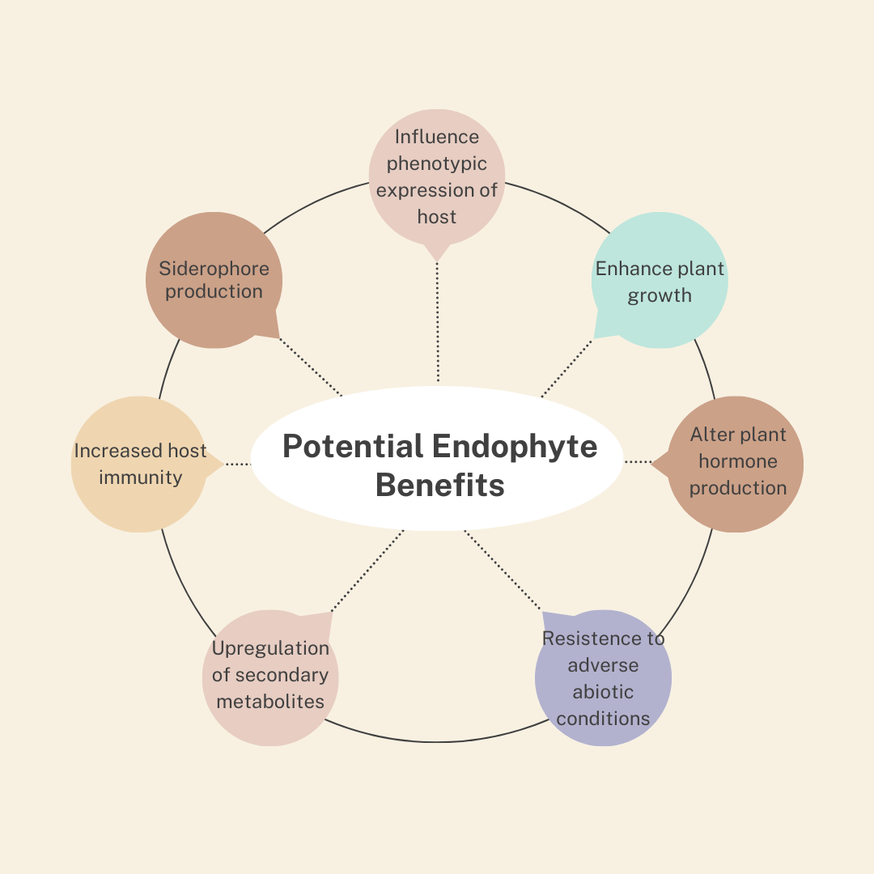
Figure 23.1. Some of the potential benefits that fungal endophytes may confer to agricultural crops, including Cannabis sativa.

Some selectivity can be imposed when preparing compost tea by adjusting starting materials and brewing conditions (e.g., time, temperature, and oxygen levels). Specific microbial inocula or products may be added to introduce beneficial species. By working with endophytes, growers can select microbes capable of forming symbiotic, internal relationships with Cannabis.
Endophytes found within healthy Cannabis plants represent a reservoir of potential beneficial mutualists. However, latent parasites may also exist within Cannabis. Therefore, isolating an endophyte from healthy Cannabis tissue does not guarantee it is a mutualist. Endophytes can be screened and reapplied, alone or in combination, to manipulate plant health and behavior.

Endophyte Isolation
Isolating endophytes requires relatively simple materials and tools (see protocols at the end of this chapter). A sterile laboratory environment is highly recommended to prevent contamination. Laminar flow hoods can provide a clean workspace, though biosafety cabinets are preferred since some endophytes may be human pathogens. If these are unavailable, still-air boxes and dedicated clean rooms can improve success rates. Wearing an N95 mask or higher while working and increasing room ventilation reduces the risk of inhaling pathogen spores.
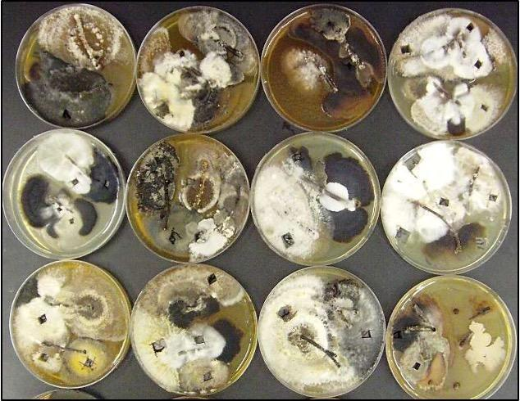
Figure 23.2. Endophytes being isolated from stem sections of American Chestnut on PDA.
Endophytes emerge directly from plant tissue (Fig. 2). While it is easy to discard contaminants growing away from the plant tissue on a culture plate, those growing near plant tissue may be difficult to distinguish from true endophytes. Many contaminant molds can also function as endophytes, making sterile culture techniques essential. Control plates should be included to monitor contamination. The goal of these procedures is to isolate beneficial endophytes from plant tissue (Fig. 3). Any endophyte found within Cannabis tissue inherently has the ability to infect and persist within a Cannabis plant. Using healthy Cannabis tissue reduces the likelihood of isolating harmful endophytes.
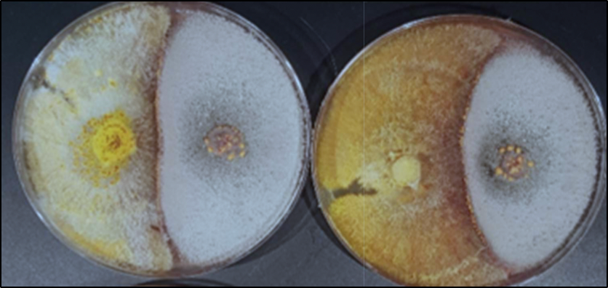
Figure 23.3. Dual culture assay of an endophyte vs a plant pathogen plated on PDA to determine if the endophyte offers protection to the plant from the pathogen (Cryphonectria parasitica on the left).

The selection of plant material for endophyte isolation is crucial. Outdoor plants will likely have different endophyte populations than indoor plants. Geographic location and land use patterns influence endophyte populations, especially for outdoor plants. There is growing interest in landrace and feral genetics from ancient areas of Cannabis cultivation, as their endophytes have coevolved naturally with Cannabis. Additionally, cultivar genotype and tissue type are key factors in determining endophyte populations and subsequent isolations.

Isolate Identification
Endophytes can be difficult to identify morphologically, as many do not form fruiting structures in culture, which are typically necessary for accurate identification. Even with molecular techniques, many endophytes remain undescribed, and genomic databases are incomplete. While precise identification is not always required, it is important to be aware of the risk of isolating and amplifying latent pathogens. Some common endophytes, such as Aspergillus niger, a species of concern as a human pathogen, do produce diagnostic cultures and spores (usually asexual conidia) that can be readily identified.
Dual-culture assays provide a simple method for evaluating an endophyte's ability to antagonize specific pathogens (Fig. 4). While plant-host-mediated interactions are not accounted for, these assays can help assess an endophyte’s potential benefits. Endophytes can be tested against various pathogens or specific threats relevant to the grower’s conditions.
To perform dual-culture assays, plates with media are inoculated equidistantly with a pathogen and an endophyte (see the protocol at the end of this chapter). The organisms are allowed to interact, and the results are observed and measured. Evaluations can include quantitative assessments, such as culture size ratios, and qualitative observations, such as pigmentation and inhibition zones.

Endophyte Consortia
Applying endophytes as consortia may be more effective than using individual isolates in agriculture (Carroll, 1991). Endophytes can be isolated and recombined in specific proportions or mass-cultured from plant tissue without selection. If first isolated, they may be screened for beneficial properties before being recombined into an agricultural inoculum.

In Planta Testing
Any endophyte inoculum developed should be tested on a small group of plants before widespread application. Although the risk is low when applying Cannabis-indigenous endophytes to Cannabis plants, it is essential to confirm they do not cause harm. Sound experimental design and statistical analysis should be used to evaluate the efficacy of endophyte treatments in real-world conditions. Endophytes interact differently with various host cultivars and across different environments. While farmer-isolated endophytes may offer unique benefits suited to specific growing systems where commercial inocula cannot, their development and application can be time- and resource-intensive.
Protocols for endophyte extraction, isolation, and dual culture assays
Materials needed:
- 95% ethanol (Everclear)

- Household bleach (5.25% v/v)

- Scalpels, clippers if necessary.

- Prepared plates with desired media. Standard Potato Dextrose Agar (PDA) is acceptable. Malt Extract Agar (MEA) is also widely available and will work. Differences in media may affect endophyte recovery by favoring or disfavoring species based on growth preferences. Antibacterial additives (streptomycin, tetracycline, chloramphenicol, rose bengal, ect) may be added to select against bacteria and for fast growing fungi.

- A clean working lab space with a lamp, burner, bactoincinerator, or glass bead sterilizer.

Extraction protocol:

- Cut desired sections of plant tissue into manageable sections and surface sterilize them by serially submerging each in 95% ethanol for 30 seconds, a sodium hypochlorite solution (5.25% v/v) for 3 minutes, 75% ethanol for 30 seconds, followed by sterile, distilled water for 30 seconds.

- Plate each piece of tissue on clean plates of media. To ensure the adequacy of your surface sterilization procedures, imprint each piece of tissue onto a media plate before moving it to its growth plate, and/or plate aliquots of the sterile rinse water. If organisms grow on the imprint or aliquot plates, the plates with the relevant plant tissue should also be assumed contaminated with non-endophytes. Seal plates with parafilm and incubate at room temperature in a dark place. Plates should be stored upside down during incubation to prevent condensation from dripping onto cultures.

- As endophytes emerge from the plant tissue, individual colonies should be cut out and re-plated on new media plates to isolate individuals. It is important to monitor plates closely and perform isolations as soon as possible; some fungi will quickly outcompete others in culture. Endophytes are highly diverse within small tissue samples. Reducing the size of tissue sections to be plated may increase recovery of slow growing isolates.

Qualitative screening method protocol:
Qualitative analysis allows a large number of endophytes to be screened for activity and is not prone to variations in growth speed of isolates in vitro that may not reflect in planta activity.

- Endophytes can be scored based on their ability to (A=1) deadlock in culture, (B=2) deadlock at a distance, (C=3) partially overgrow the blight fungus, or (D=4) completely overgrow the pathogen with replacement by the endophyte. The same values are assigned as negatives in the cases where the pathogen outcompeted the candidate endophyte. Positive values in any of these categories indicate antagonism, with A-type considered the least strong, B-type intermediate (indicative of possible excretion of antimicrobials), and C- and D-types the strongest.

- A single numerical antagonism index (AI) may be assigned to each endophyte, calculated with formula: AI = [A (n×1) + B (n×2) + C (n×3) + D (n×4)] / N; Where n= the frequency of each interaction type between a particular endophyte and the pathogen, and N= the total number of replicates performed for each pairing. A specific point, based on time or extent of culture growth, may be set at which to calculate AI for comparison among numerous candidate endophytes.

- Characterize the top performing endophytes and devise inoculation mechanisms appropriate for their biology (i.e. Are they safe species for humans to work with? How easily are they cultured? Do they produce spores in culture? Are applied inocula preparations effective at introducing the organism into new host plants?).

Suggested mass culture protocol:
- Sterilize plant tissue sections as described above (Endophyte isolation).

- Following sterilization, rather than plating tissue sections onto solid agar media, drop them into flasks of liquid media and place on a stir plate or shaker table. Endophytes will emerge into the liquid media in a nonselective manner. You will not have selective control over the population of the resulting slurry of endophytes, which may be prone to domination by the fastest or most aggressive individuals or species. Additions may be added, such as rose bengal, which may broaden the species recovered from plant samples by slowing the growth among aggressive species.

- Dilute and apply mycelial suspension onto desired plant parts of the target crop plants. Specific inocula density can be standardized by measuring the density of the original culture (hyphae or spores) using a slide with a counting-chamber and diluting accordingly.

In summary:
- Cannabis plants contain communities of microorganisms inside of the plant tissue that do not cause any apparent harm. These organisms are referred to as endophytes.
- By applying microbial endophyte products to Cannabis plants growers can influence and enhance the plants microbiome which may improve plant fitness
- Endophyte inocula can be purchased or can be made on the farm

